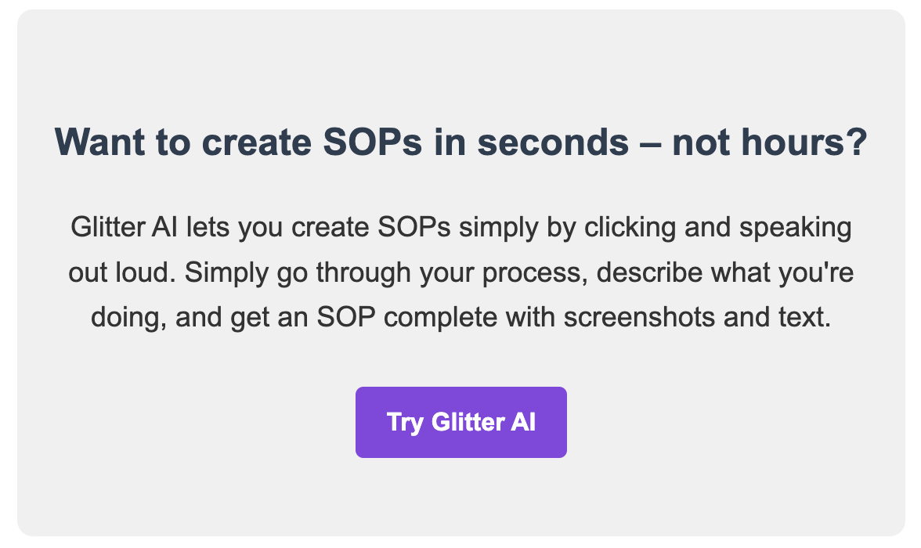

www.glitter.io

[Procedure Name] - Standard Operating Procedure

Table of Contents
- Purpose
- Scope
- Responsibilities
- Definitions
- Equipment and Materials
- Safety Precautions
- Procedure
- Quality Control
- Documentation
- References

1. Purpose
[Clearly state the purpose of this SOP, explaining why it exists and what it aims to achieve]

2. Scope
[Define the boundaries of this SOP, including which departments, processes, or situations it applies to]

3. Responsibilities
Role | Responsibilities
[Role 1] | [List of responsibilities for Role 1]
[Role 2] | [List of responsibilities for Role 2]
[Role 3] | [List of responsibilities for Role 3]

4. Definitions
[Term 1]
[Definition of Term 1]
[Term 2]
[Definition of Term 2]
[Term 3]
[Definition of Term 3]

5. Equipment and Materials
- [Equipment/Material 1]
- [Equipment/Material 2]
- [Equipment/Material 3]

6. Safety Precautions
Warning: [Key safety warning related to this procedure]
- [Safety precaution 1]
- [Safety precaution 2]
- [Safety precaution 3]

7. Procedure
- [Step 1 Title]
[Detailed description of step 1]

- [Step 2 Title]
[Detailed description of step 2]
Note: [Important information or tip related to this step]
- [Step 3 Title]
[Detailed description of step 3]

8. Quality Control
[Description of quality control measures for this procedure]
- [Quality control check 1]
- [Quality control check 2]
- [Quality control check 3]

9. Documentation
[Description of required documentation for this procedure]
- [Document 1]
- [Document 2]
- [Document 3]

10. References
- [Reference 1]
- [Reference 2]
- [Reference 3]
SOP Number: [SOP-XXX-YY]
Revision Number: [Z]
Effective Date: [MM/DD/YYYY]
Last Reviewed: [MM/DD/YYYY]
Next Review Date: [MM/DD/YYYY]
Approved by: [Name and Title of Approver]

