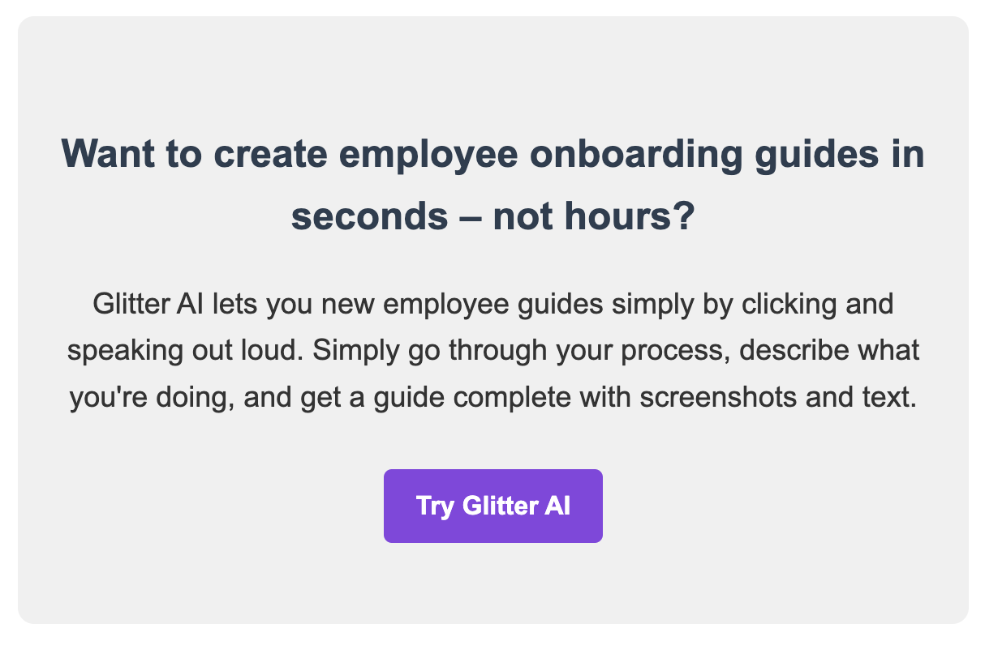

www.glitter.io

[Company Name] Employee Onboarding Guide

Table of Contents
- Introduction
- Pre-arrival Preparations
- First Day Procedures
- First Week Activities
- Training and Orientation
- Resources and Tools
- Key Policies and Procedures
- FAQs
- Important Contacts

1. Introduction
Welcome to [Company Name]! This manual will guide you through our employee onboarding process, ensuring a smooth transition into your new role. Our goal is to help you feel welcomed, prepared, and set up for success.

2. Pre-arrival Preparations

2.1 Documentation
- Signed offer letter
- Completed W-4 form
- I-9 form and required identification
- [Any other required documents]

2.2 IT Setup
Our IT department will prepare:
- Your company email account
- Access to necessary software and systems
- [Any other IT preparations]
Note: Please respond promptly to any emails from HR or IT to ensure everything is ready for your first day.

3. First Day Procedures

3.1 Arrival and Check-in
- Arrive at [office address] at [time]
- Check in at the reception desk
- Meet your assigned onboarding buddy
- Receive your employee ID and access card

3.2 Orientation Session
- Company overview presentation
- Tour of the office facilities
- Introduction to your team
- Setup of workstation and equipment

4. First Week Activities
- Daily check-ins with your manager
- Team lunch (usually on day 3)
- IT systems training
- Review of job responsibilities and expectations
- Begin role-specific training

5. Training and Orientation

5.1 Mandatory Training
- Company values and culture
- Sexual harassment prevention
- Data security and privacy
- [Any other mandatory training]

5.2 Role-specific Training
[Details about role-specific training programs]
Tip: Keep track of your training progress in our Learning Management System (LMS).

6. Resources and Tools
- Employee handbook
- Company intranet
- Project management tools
- Communication platforms
- [Any other relevant resources]

7. Key Policies and Procedures
- Code of conduct
- Attendance and leave policies
- Expense reimbursement process
- Performance review cycle
- [Any other important policies]
Important: Please review all policies in the employee handbook thoroughly.

8. FAQs
Q: What should I wear to work?
A: Our dress code is [describe dress code]. [Any additional details about appropriate attire]
Q: How do I request time off?
A: Time off requests are submitted through our HR portal. [Instructions on how to access and use the portal]
Q: Who do I contact if I'm sick and can't come to work?
A: Please notify your direct manager and HR by [preferred method of communication] as soon as possible.

9. Important Contacts
- HR Department: [email and phone number]
- IT Support: [email and phone number]
- Your Manager: [name, email, and phone number]
- Your Onboarding Buddy: [name, email, and phone number]
© [Year] [Company Name]. All rights reserved.

