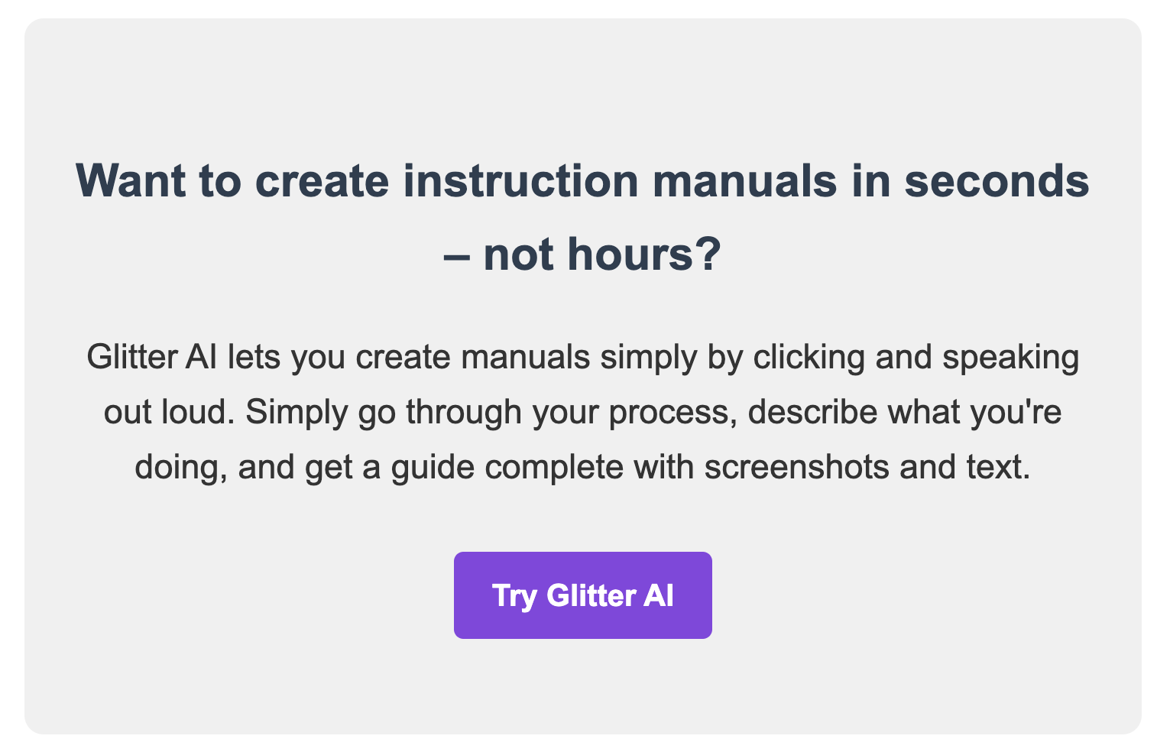

www.glitter.io


[App Name] User Guide

Table of Contents
- Introduction
- System Requirements
- Registration
- Getting Started
- User Interface
- Features
- Troubleshooting
- FAQs
- Support

1. Introduction
Welcome to [App Name]! This guide will walk you through the registration process, features, and use of our application. [Brief description of the App and its main purpose]

2. System Requirements

Supported Browsers:
- Google Chrome (version 90 or later)
- Mozilla Firefox (version 88 or later)
- Safari (version 14 or later)
- Microsoft Edge (version 90 or later)

Additional Requirements:
- Stable internet connection
- JavaScript enabled
- Cookies enabled

Note: For the best experience, we recommend using the latest version of your preferred browser.

3. Registration
- Navigate to [App URL]
- Click on the "Sign Up" or "Register" button
- Fill in the required information:
  - Email address
  - Password
  - [Any other required fields]
- Click "Create Account"
- Verify your email address by clicking the link sent to your inbox

4. Getting Started

4.1 Logging In
- Go to [App URL]
- Enter your email and password
- Click "Log In"

4.2 Initial Setup
[Any necessary setup steps after first login, e.g., profile completion, preferences]



5. User Interface
[Overview of the main user interface elements]

5.1 Navigation Bar
[Description of navigation bar items and their functions]

5.2 Dashboard
[Description of the main dashboard and its components]

5.3 User Settings
[How to access and modify user settings]

6. Features

6.1 [Feature 1]
[Description of Feature 1]
- [Step 1 to use Feature 1]
- [Step 2 to use Feature 1]
- [Step 3 to use Feature 1]

6.2 [Feature 2]
[Description of Feature 2]
- [Step 1 to use Feature 2]
- [Step 2 to use Feature 2]
- [Step 3 to use Feature 2]

Tip: [Helpful tip for using Feature 2 effectively]

7. Troubleshooting

Common Issues and Solutions
Can't log in
Possible causes:
- Incorrect email or password
- Account not verified
- Browser cookies disabled
Solutions:
- Double-check your credentials
- Check your email for the verification link
- Enable cookies in your browser settings
Page not loading correctly
Possible causes:
- Outdated browser
- JavaScript disabled
- Slow internet connection
Solutions:
- Update your browser to the latest version
- Enable JavaScript in your browser settings
- Check your internet connection or try again later
Warning: If you encounter persistent issues, please contact our support team before attempting any advanced troubleshooting steps.

8. FAQs
Q: How do I reset my password?
A: Click on the "Forgot Password" link on the login page, enter your email address, and follow the instructions sent to your inbox.
Q: Is my data secure?
A: Yes, we use industry-standard encryption and security measures to protect your data. For more information, please review our Privacy Policy.
Q: Can I use [App Name] on my mobile device?
A: Yes, [App Name] is fully responsive and can be accessed through your mobile device's web browser.

9. Support
If you need further assistance, please contact our support team:
- Email: [support email address]
- Live Chat: Available on our website during business hours
- Help Center: [link to help center]
© [Year] [Company Name]. All rights reserved.

